PFS Scenario #6-11: The Slave Master's Mirror
"Take 10" Knowledge

Mission: Infiltrate Stonespire Island by acting as slaves in order to locate and subdue the veiled woman scrying on Absalom nobles. Retrieve the mirror the woman used as a focus.

Location: Stonespire Island is a sizable island located off-shore of Katapesh in the Obari Ocean. Naturally inhabited by Gnolls, Stonespire Island has been colonized by pirates that have established the city of Okeno:
- Okeno: Under the control of Katapesh, this city rates as the third largest in the nation. Its primary source of commerce is the Fleshfairs, the largest slave markets in the Inner Sea region. Gnolls in the region frequently visit the city to buy slaves for their own purposes.
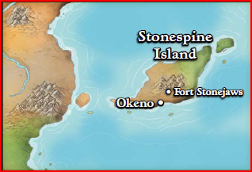
Key NPCs:
- Ambrus Valsin: Venture-Captain and chamberlain of the Grand Lodge in Absalom.
- Lady Darchana Madinani: archdean of the Arcanamirium magical university, she holds a seat on the Lesser Council and advocates for the sharing of magical research.
- Pasha Muhlia al’Jakri: missing former Pathfinder agent known for her penchant for deception and revenge. She has been associated with the Aspis Consortium agents Aglorn and Tancred Desimire.

Other Information:
- Gnolls: humanoids with hyena-like features, they collect such creatures as pets and are notoriously lazy.
- Scrying: a spell used to observe an area around a creature requiring physical knowledge of the subject to link the sensor to the intended target.
- Storage: an experimental magical chest is being used to store your gear; one item per person can be shrunk for easy access by Lady Darchana.

