Character Name: Asevenoone [A701]
Race: Android
Class [Theme]: Technomancer [Scholar]
Height: 7' 1” Weight: 271 lbs.


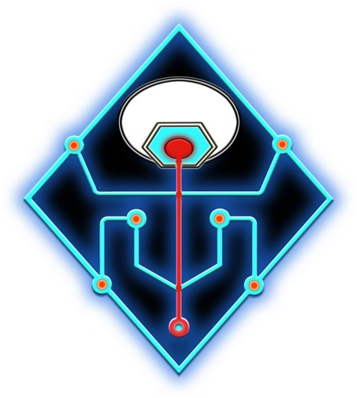
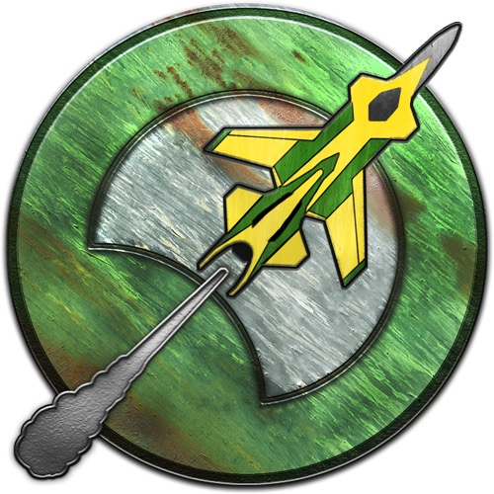

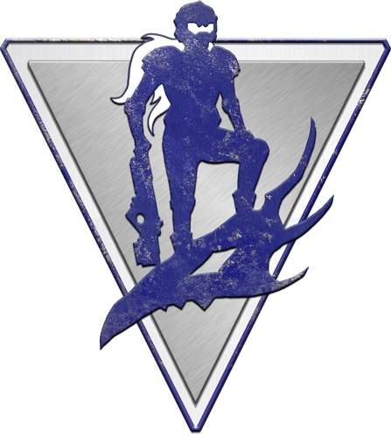
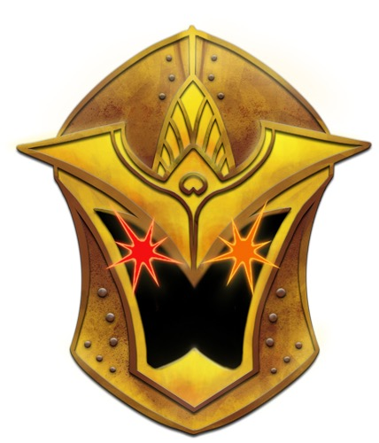
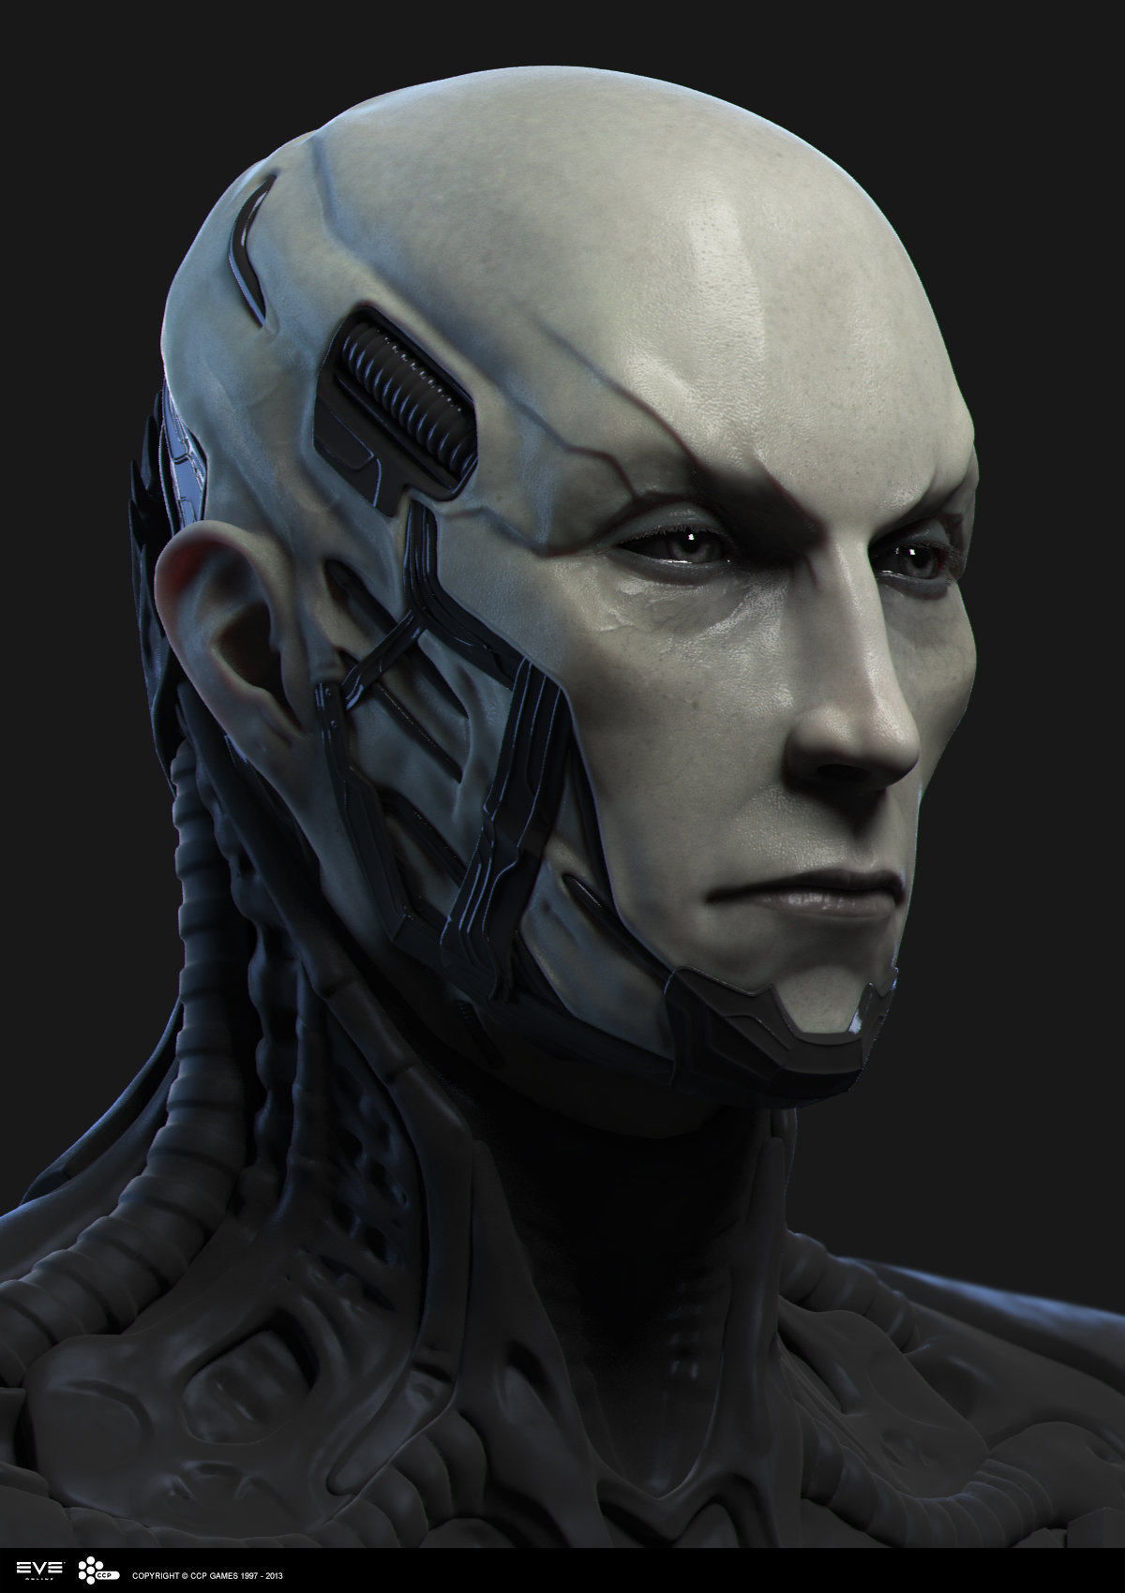

Charisma: 08
Physical Description: Asevenoone wears graphite carbon skin armor, stands very tall, has a bluish skin tone, and circuitry woven throughout.
Bio: Asevenoone was assembled on Aballon by anacites; a spark of sentience was given to accomplish engineering tasks; but Asevenoone wanted more. He abandoned his assignment, and sought reprogramming that would make him good at everything. Meeting and understanding new organic life is his prime directive.
Day Job: Profession [Electrician]
Hook: “This won’t be difficult. Press here.”
Player Name: Dale Thurber
PFS #: 28982-701

Character Name:
Race:
Class [Theme]:
Height: ’ ” Weight: lbs.

Charisma:
Physical Description:

Bio:

Day Job:
Hook:
Player Name:
PFS #: -701

