Nilith

Giant

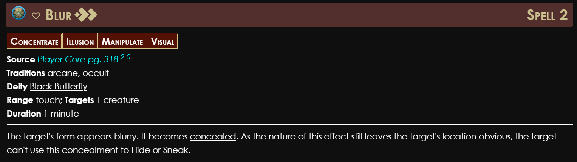

Spider

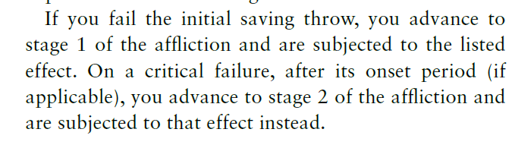

Statue

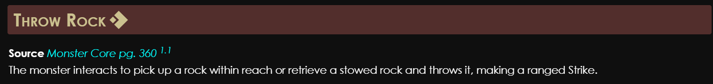

Armor

Briefing

Vampires

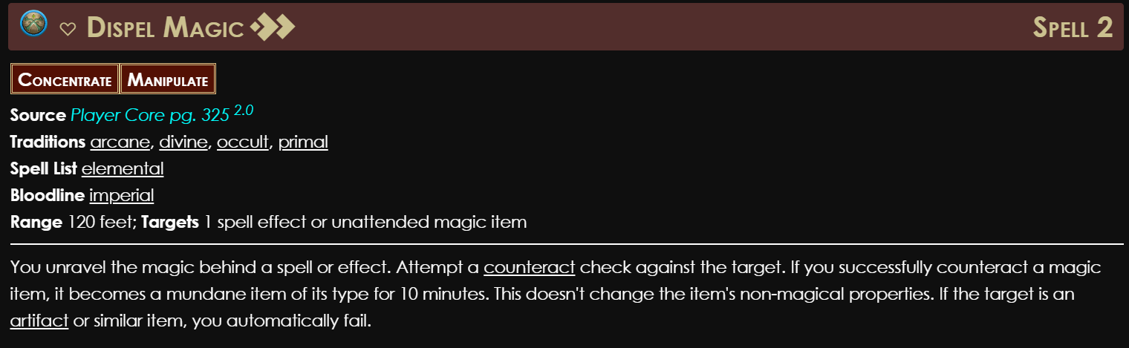

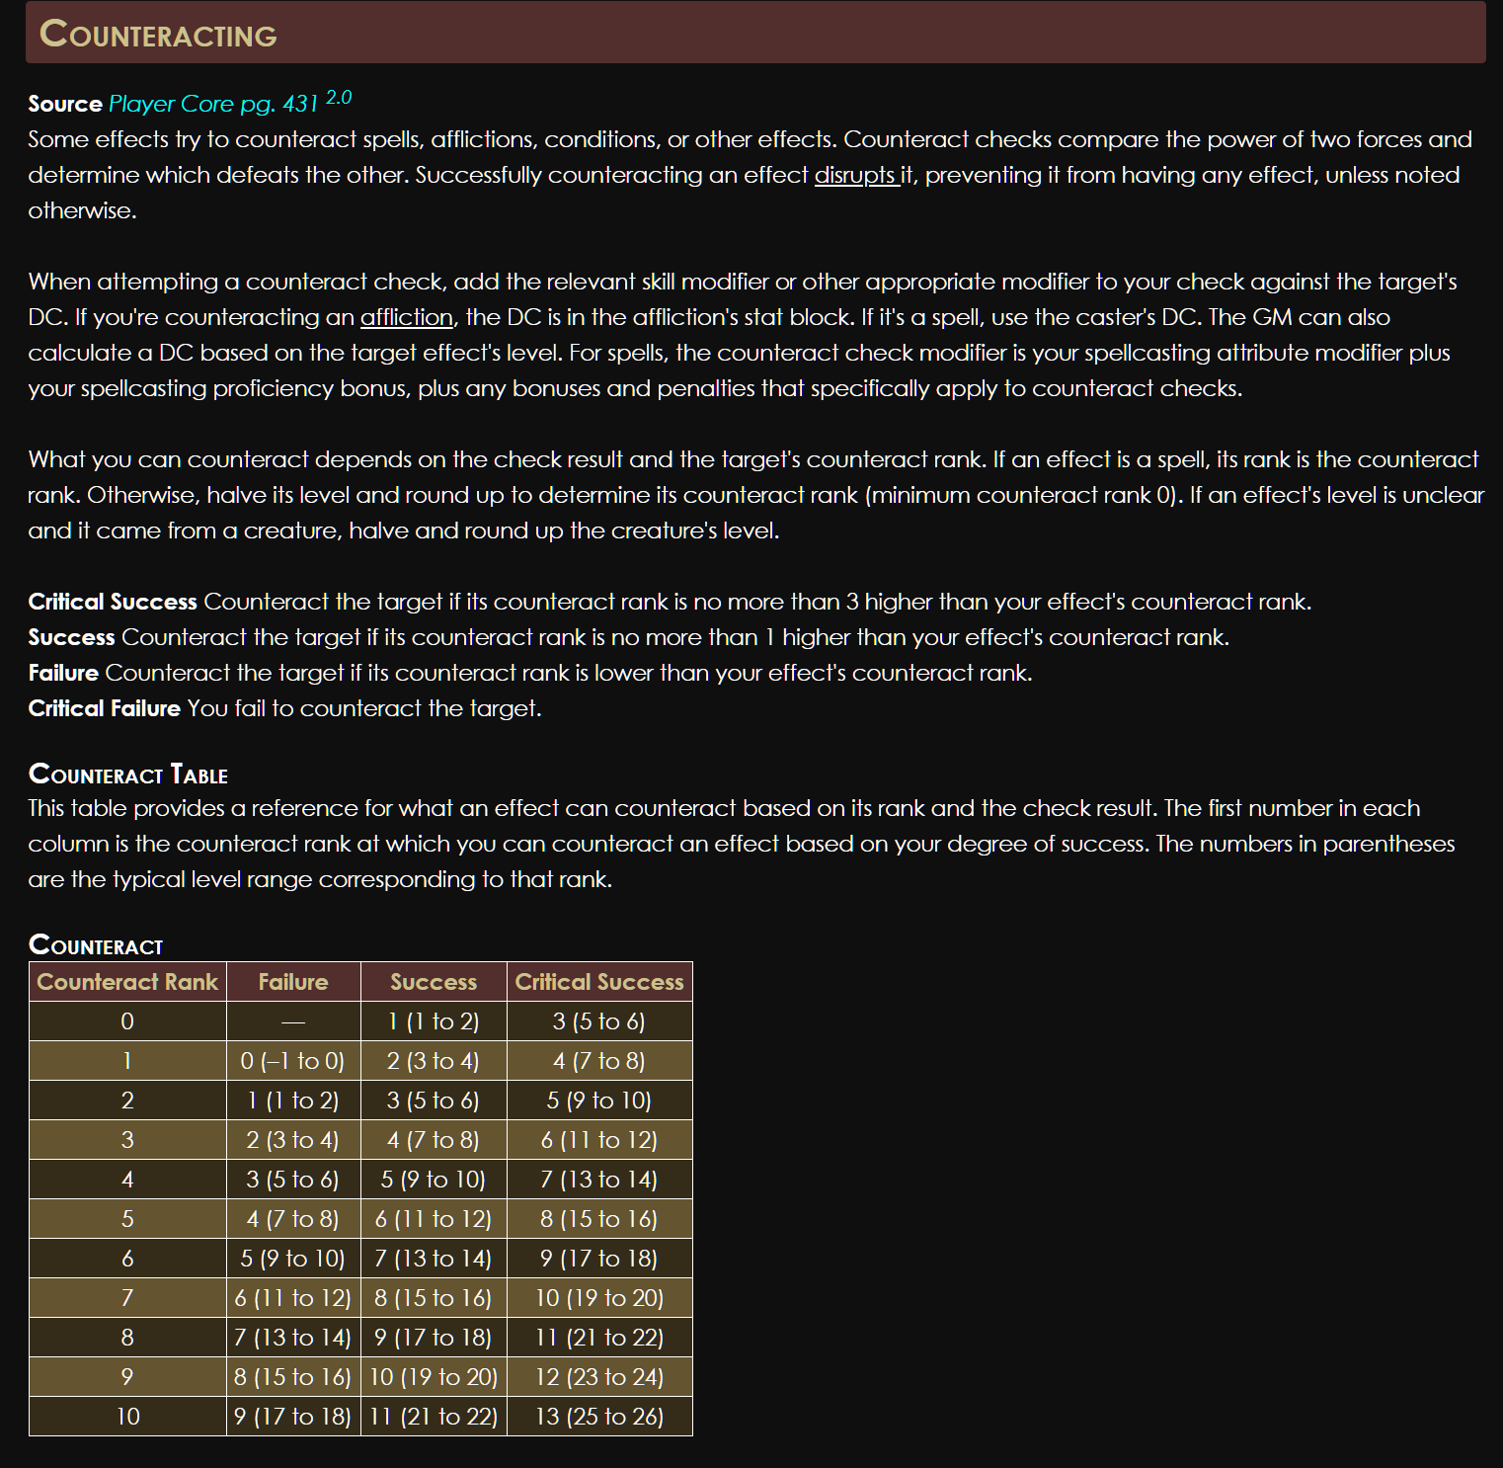

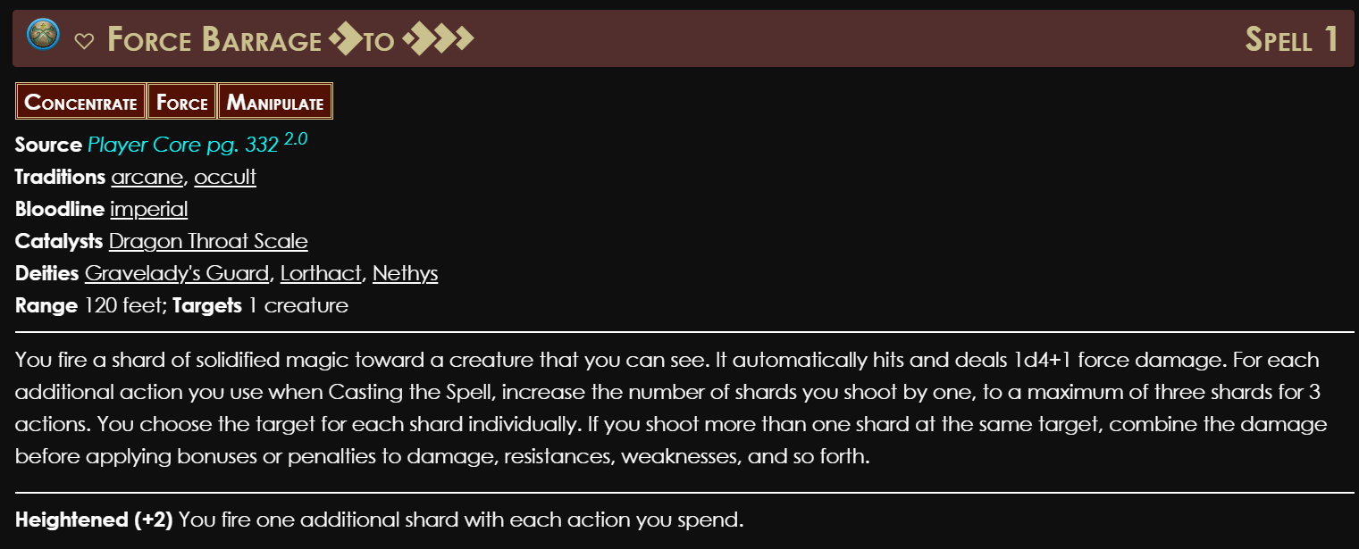

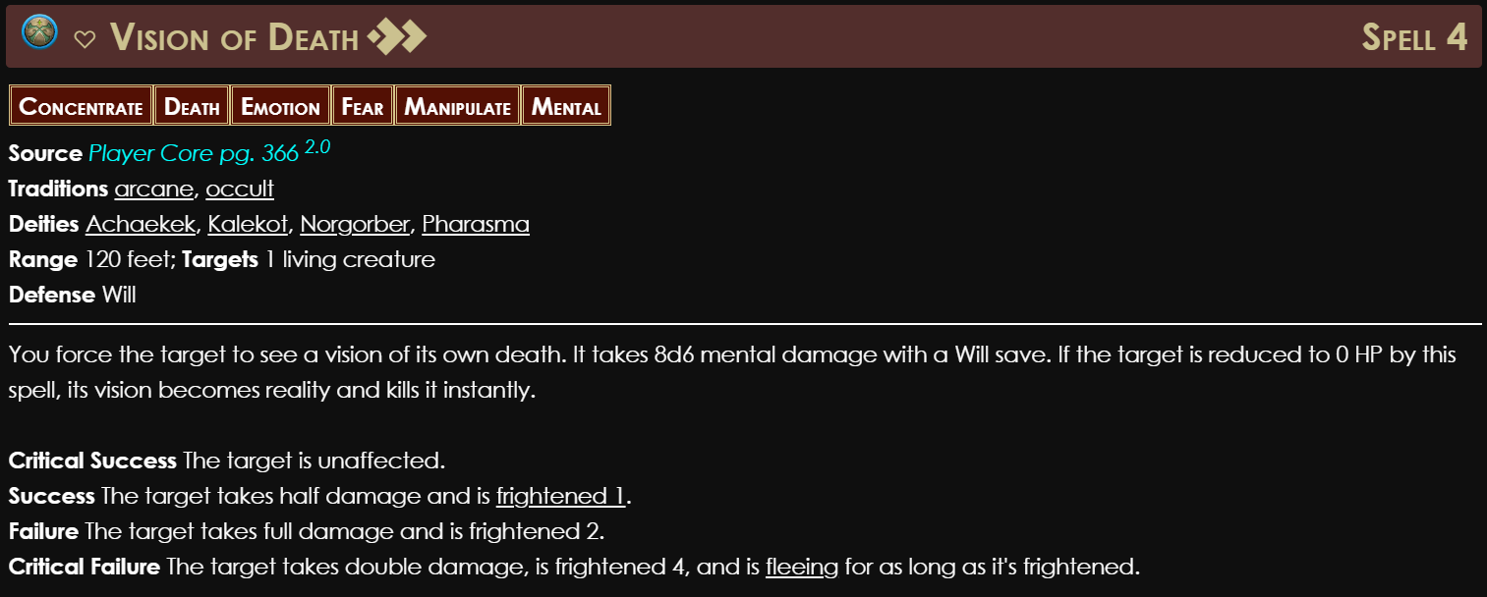

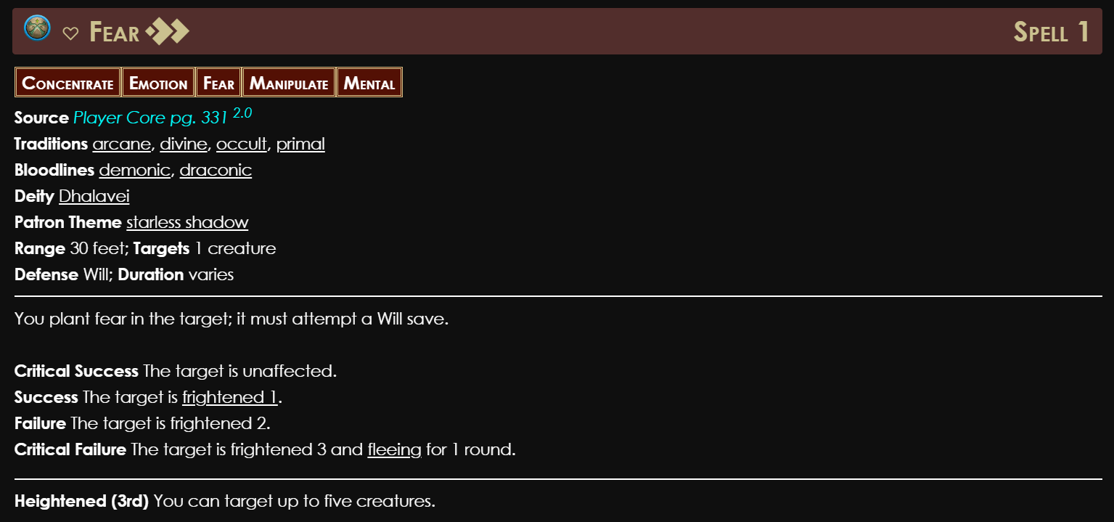

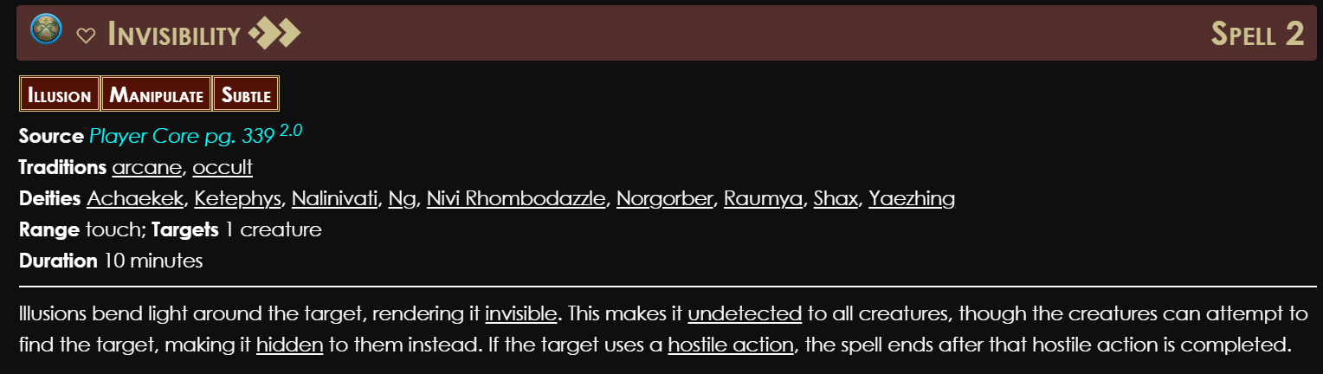

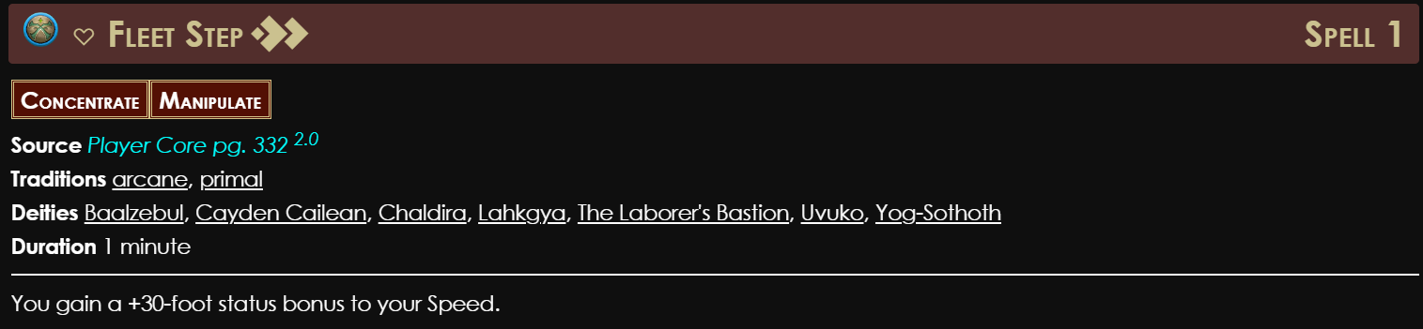

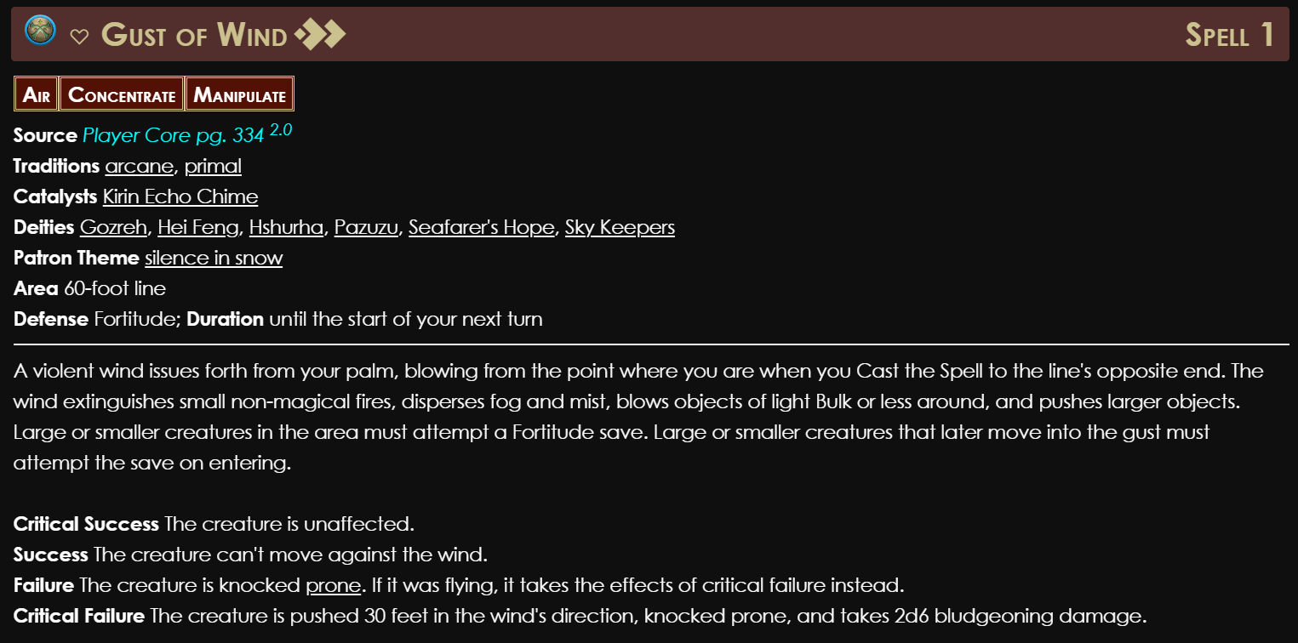

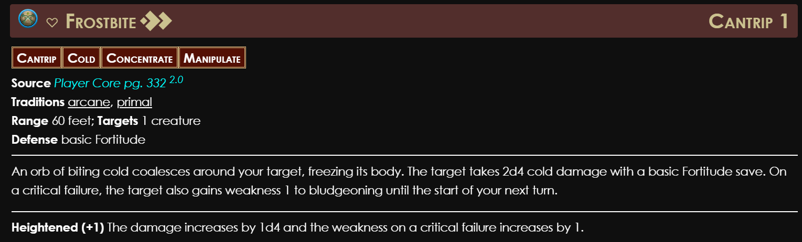

Penumbra

