SPIDER SWARM
N Diminutive vermin (swarm)
Init +3; Senses darkvision 60 ft., tremorsense 30 ft.; Perception +4
DEFENSE
AC 17, touch 17, flat-footed 14 (+3 Dex, +4 size)
hp 9 (2d8)
Fort +3, Ref +3, Will +0
Defensive Abilities swarm traits; Immune mind-affecting effects, weapon damage
OFFENSE
Speed 20 ft., climb 20 ft.
Melee swarm (1d6 plus poison and distraction)
Space 10 ft.; Reach 0 ft.
Special Attacks distraction (DC 11)
STATISTICS
Str 1, Dex 17, Con 10, Int —, Wis 10, Cha 2
Base Atk +1; CMB —; CMD —
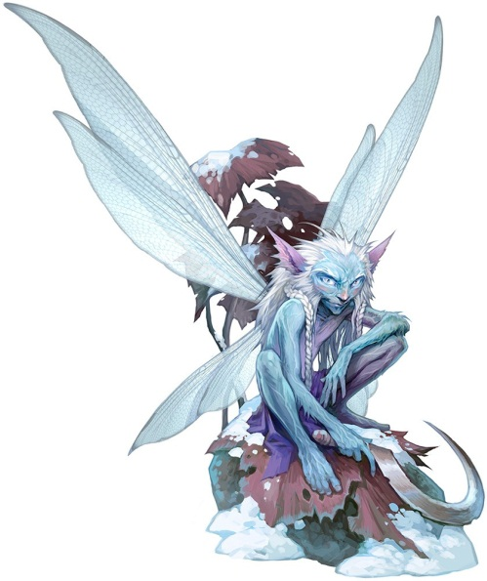
Skills Climb +11, Perception +4; Racial Modifiers +4 Perception; uses Dexterity for Climb checks
SPECIAL ABILITIES
Poison (Ex) Swarm—injury; save Fort DC 11; frequency 1/round for 2 rounds; effect 1d2 Str; cure 1 save. The save DC is Constitution-based.

ATOMIE
CN Diminutive fey
Init +7; Senses low-light vision; Perception +7
DEFENSE
AC 17, touch 17, flat-footed 14 (+3 Dex, +4 size)
hp 9 (2d6+2)
Fort +1, Ref +6, Will +5
DR 2/cold iron
OFFENSE
Speed 20 ft., fly 50 ft. (good)
Melee rapier +8 (1d2–2/18–20)
Space 1 ft.; Reach 0 ft.
Special Attacks sneak attack +1d6
Spell-Like Abilities (CL 6th; concentration +10)
At will—dancing lights, reduce person (DC 15)
3/day—blink, entangle (DC 15), invisibility (self only)
1/day—shrink item
STATISTICS
Str 6, Dex 17, Con 13, Int 11, Wis 14, Cha 18
Base Atk +1; CMB +0; CMD 8
Feats Improved InitiativeB, Weapon Finesse
Skills Acrobatics +8 (+4 when jumping), Bluff +9, Escape Artist +7,
Fly +18, Perception +7, Sense Motive +6, Stealth +20
Languages Common, Sylvan; speak with animals
*This atomie is a blended version; the Bestiary version does not have entangle*
RAT SWARM
N Tiny animal (swarm)
Init +6; Senses low-light vision, scent; Perception +8
DEFENSE
AC 14, touch 14, flat-footed 12 (+2 Dex, +2 size)
hp 16 (3d8+3)
Fort +4, Ref +5, Will +2
Defensive Abilities swarm traits
OFFENSE
Speed 15 ft., climb 15 ft., swim 15 ft.
Melee swarm (1d6 plus disease)
Space 10 ft.; Reach 0 ft.
Special Attacks disease, distraction (DC 12)
STATISTICS
Str 2, Dex 15, Con 13, Int 2, Wis 13, Cha 2
Base Atk +2; CMB —; CMD —
Feats Improved Initiative, Skill Focus (Perception)
Skills Acrobatics +6, Climb +10, Perception +8, Stealth +14, Swim +10; Racial Modifiers uses Dex to modify Climb and Swim
SPECIAL ABILITIES
Disease (Ex) Filth fever: Swarm—injury; save Fort DC 12; onset 1d3 days; frequency 1/day; effect 1d3 Dex damage and 1d3 Con damage; cure 2 consecutive saves. The save DC is Constitution-based.

GNOME WARRIORS
Male gnome warrior 1
NG Small humanoid (gnome)
Init +0; senses low-light vision; Perception +1
DEFENSE
AC 16, touch 11, flat-footed 16 (+1 size, +4 armor, +1 shield)
hp 7 (1d8+2)
Fort +4, Ref +0, Will -1; +2 vs. illusions, +2 vs. mind-affecting effects
OFFENSE
Speed: 20 ft. (4 squares)
Melee +2 long sword (1d6/19-20)
Ranged +3 light crossbow (1d6/19-20)
Space/Reach: 5 ft./5 ft.
Special attacks +1 on attack rolls against
goblinoid and reptilian humanoids
STATISTICS
Str 11, Dex 11, Con 14, Int 10, Wis 9, Cha 8
BAB +1; CMB +0; CMD 10
Skills Hide +3, Listen +1, Spot +1
Feats Weapon Focus (light crossbow)
Gear chain shirt, light wooden shield, long sword, light crossbow, 10 bolts

WOLVERINE
N Medium animal
Init +2; Senses low-light vision, scent; Perception +10
DEFENSE
AC 14, touch 12, flat-footed 12 (+2 Dex, +2 natural)
hp 22 (3d8+9)
Fort +5, Ref +5, Will +2
OFFENSE
Speed 30 ft., burrow 10 ft., climb 10 ft.
Melee 2 claws +4 (1d6+2), bite +4 (1d4+2)
Special Attacks rage
STATISTICS
Str 15, Dex 15, Con 15, Int 2, Wis 12, Cha 10
Base Atk +2; CMB +4; CMD 16 (20 vs. trip)
Feats Skill Focus (Perception), Toughness
Skills Climb +10, Perception +10
SPECIAL ABILITIES
Rage (Ex) A wolverine that takes damage in combat flies into a rage on its next turn, clawing and biting madly until either it or its opponent is dead. It gains +4 to Strength, +4 to Constitution, and –2 to AC. The creature cannot end its rage voluntarily.

YOUNG VENOMOUS SNAKE
N Small animal
Init +7; Senses low-light vision, scent; Perception +9
DEFENSE
AC 15, touch 14, flat-footed 12 (+3 Dex, +1 size, +1 natural)
hp 9 (2d8)
Fort +3, Ref +6, Will +1
OFFENSE
Speed 20 ft., climb 20 ft., swim 20 ft.
Melee bite +5 (1d3–3 plus poison)
STATISTICS
Str 4, Dex 17, Con 10, Int 1, Wis 13, Cha 2
Base Atk +1; CMB -3; CMD 10 (can't be tripped)
Feats Improved Initiative, Weapon Finesse
Skills Acrobatics +11, Climb +7, Perception +9, Stealth +11, Swim +7; Racial Modifiers +4 Perception, +4 Stealth, +8 Acrobatics; modifies Climb and Swim with Dexterity
SPECIAL ABILITIES
Poison (Ex) Bite—injury; save Fort DC 11; frequency 1/round for 6 rounds; effect 1d2 Con; cure 1 save.

VENOMOUS SNAKE
N Medium animal
Init +5; Senses low-light vision, scent; Perception +9
DEFENSE
AC 14, touch 11, flat-footed 13 (+1 Dex, +3 natural)
hp 13 (2d8+4)
Fort +5, Ref +4, Will +1
OFFENSE
Speed 20 ft., climb 20 ft., swim 20 ft.
Melee bite +2 (1d4–1 plus poison)
STATISTICS
Str 8, Dex 13, Con 14, Int 1, Wis 13, Cha 2
Base Atk +1; CMB +0; CMD 11 (can't be tripped)
Feats Improved Initiative, Weapon FinesseB
Skills Acrobatics +9, Climb +9, Perception +9, Stealth +9, Swim +9; Racial Modifiers +4 Perception, +4 Stealth, +8 Acrobatics; modifies Climb and Swim with Dexterity
SPECIAL ABILITIES
Poison (Ex) Bite—injury; save Fort DC 13; frequency 1/round for 6 rounds; effect 1d2 Con; cure 1 save.
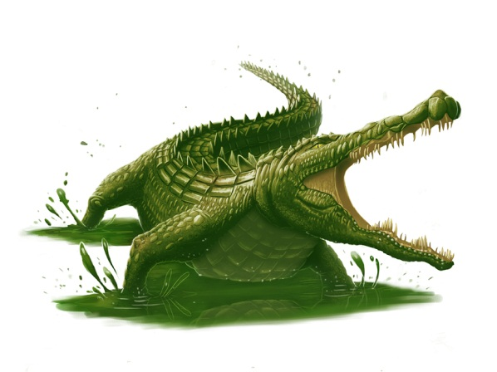
CROCODILE
N Large animal
Init +1; Senses low-light vision; Perception +8
DEFENSE
AC 14, touch 10, flat-footed 13 (+1 Dex, +4 natural, –1 size)
hp 22 (3d8+9)
Fort +6, Ref +4, Will +2
OFFENSE
Speed 20 ft., swim 30 ft.; sprint
Melee bite +5 (1d8+4 plus grab) and tail slap +0 (1d12+2)
Space 10 ft.; Reach 5 ft.
Special Attacks death roll (1d8+6 plus trip)
STATISTICS
Str 19, Dex 12, Con 17, Int 1, Wis 12, Cha 2
Base Atk +2; CMB +7 (+11 grapple); CMD 18 (22 vs. trip)
Feats Skill Focus (Perception, Stealth)
Skills Perception +8, Stealth +5 (+13 in water), Swim +12; Racial Modifiers +8 on Stealth in water
SQ hold breath
SPECIAL ABILITIES
Death Roll (Ex) When grappling a foe of its size or smaller, a crocodile can perform a death roll upon making a successful grapple check. As it clings to its foe, it tucks in its legs and rolls rapidly, twisting and wrenching its victim. The crocodile inflicts its bite damage and knocks the creature prone. If successful, the crocodile maintains its grapple.
Hold Breath (Ex) A crocodile can hold its breath for a number of rounds equal to 4 times its Constitution score before it risks drowning.
Sprint (Ex) Once per minute a crocodile may sprint, increasing its land speed to 40 feet for 1 round.

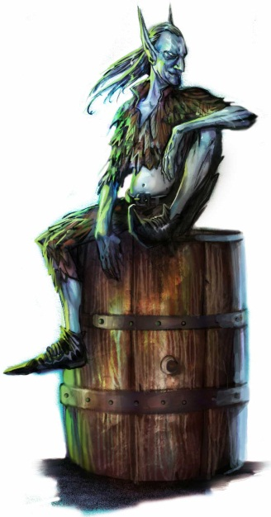
QUICKLING
CE Small fey
Init +7; Senses low-light vision; Perception +9
DEFENSE
AC 20, touch 19, flat-footed 12 (+7 Dex, +1 dodge, +1 natural, +1 size)
hp 18 (4d6+4)
Fort +2, Ref +11, Will +6
Defensive Abilities evasion, natural invisibility, supernatural speed, uncanny dodge; DR 5/cold iron
Weaknesses slow susceptibility
OFFENSE
Speed 120 ft.
Melee short sword +10 (1d4–1/19–20)
Special Attacks sneak attack +1d6
Spell-Like Abilities (CL 6th; concentration +8)
1/day—dancing lights, flare (DC 12), levitate, shatter (DC 14), ventriloquism (DC 13)
STATISTICS
Str 8, Dex 24, Con 13, Int 15, Wis 15, Cha 14
Base Atk +2; CMB +0; CMD 18
Feats Dodge, Mobility, Spring Attack, Weapon Finesse
Skills Acrobatics +14 (+50 jump), Bluff +9, Craft (any one) +9, Escape Artist +14, Perception +9, Spellcraft +6, Stealth +18, Survival +4, Use Magic Device +7
Languages Aklo, Common, Sylvan
SQ poison use
SPECIAL ABILITIES
Natural Invisibility (Su) A quickling is invisible when motionless. It loses this invisibility and remains visible for 1 round in any round in which it takes an action other than a free action.
Supernatural Speed (Su) A quickling moves with incredible speed. Save for when it remains motionless (at which point it is invisible), the quickling's shape blurs and shimmers with this speed, granting it concealment (20% miss chance). In addition, this ability grants the quickling evasion and uncanny dodge (as the rogue abilities of the same names).
Slow Susceptibility (Ex) A quickling that succumbs to a slow effect loses its supernatural speed ability and is sickened as long as the effect persists. This sickened condition persists for 1 round after the slow effect ends.

Knowledge (Nature)
DC 13 – Quicklings are malicious fey creatures that delight in striking with blinding speed and accuracy, often killing their victims without ever fully revealing themselves; the victim simply spurts blood and falls over dead, with no witnesses to the deed. Fey are resistant to manmade weapons, but cannot abide the touch of cold iron.
DC 18 – While quicklings are naturally invisible when motionless, they rarely contain themselves, and bob and twitch while standing and talking to other creatures.
DC 23 – Though related to brownies and grigs, quicklings share none of their kin's generosity or merriment, choosing instead to live a life of cruelty and viciousness. Quicklings pride themselves on insults and brutality, and frequently stalk and harass their quarry until the victim gives up the chase. Quicklings hate every other race of creature, particularly elves, gnomes, and other kinds of fey.

SPRIGGAN
CE Small humanoid (gnome)
Init +4; Senses low-light vision; Perception +7
DEFENSE
AC 17, touch 15, flat-footed 13 (+2 armor, +4 Dex, +1 size)
hp 22 (4d8+4)
Fort +5, Ref +5, Will +1
OFFENSE
Speed 20 ft.
Melee mwk morningstar +5 (1d6–1)
Ranged light crossbow +8 (1d6/19–20)
Special Attacks sneak attack +2d6
Spell-Like Abilities (CL 4th; concentration +4)
At will—flare (DC 10), scare (DC 12), shatter (DC 12)
STATISTICS
Str 9, Dex 19, Con 12, Int 10, Wis 10, Cha 9
Base Atk +3; CMB +1; CMD 15
Feats Combat Reflexes, Weapon Focus (morningstar)
Skills Climb +1, Disable Device +11, Perception +7, Sleight of Hand +11, Stealth +15; Racial Modifiers +2 Climb, +2 Disable Device, +2 Perception, +2 Sleight of Hand, +2 Stealth
Languages Aklo, Gnome
SQ size alteration, spriggan magic, spriggan skills
SPECIAL ABILITIES
Size Alteration (Su) At will as a standard action, a spriggan can change his size between Small and Large. Weapons, armor, and other objects on the spriggan's person grow proportionally when he changes size (objects revert to normal size 1 round after a spriggan releases them). While Large, a spriggan cannot use his sneak attack or his racial spell-like abilities (although if he possesses either from class levels or templates, he retains their use in both sizes).
Spriggan Magic (Ex) A spriggan gains a +1 racial bonus on concentration checks and to save DCs for all of its racial spell-like abilities.
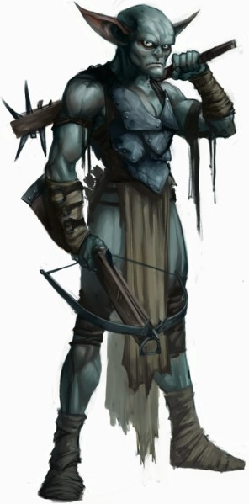
SPRIGGAN (LARGE SIZE)
CE Large humanoid (gnome)
Init +3; Senses low-light vision; Perception +7
DEFENSE
AC 14, touch 12, flat-footed 11 (+2 armor, +3 Dex, –1 size)
hp 34 (4d8+16)
Fort +8, Ref +4, Will +1
OFFENSE
Speed 30 ft.
Melee mwk morningstar +9 (2d6 +5)
Ranged light crossbow +5 (2d6/19–20)
Space 10 ft.; Reach 10 ft.
STATISTICS
Str 21, Dex 17, Con 18, Int 10, Wis 10, Cha 9
Base Atk +3; CMB +9; CMD 22
Skills Climb +7, Disable Device +10, Perception +7, Sleight of Hand +10, Stealth +6
OPEN GAME LICENSE Version 1.0a

The following text is the property of Wizards of the Coast, Inc. and is Copyright 2000 Wizards of the Coast, Inc ("Wizards"). All Rights Reserved.

1. Definitions: (a) "Contributors" means the copyright and/or trademark owners who have contributed Open Game Content; (b) "Derivative Material" means copyrighted material including derivative works and translations (including into other computer languages), potation, modification, correction, addition, extension, upgrade, improvement, compilation, abridgment or other form in which an existing work may be recast, transformed or adapted; (c) "Distribute" means to reproduce, license, rent, lease, sell, broadcast, publicly display, transmit or otherwise distribute; (d) "Open Game Content" means the game mechanic and includes the methods, procedures, processes and routines to the extent such content does not embody the Product Identity and is an enhancement over the prior art and any additional content clearly identified as Open Game Content by the Contributor, and means any work covered by this License, including translations and derivative works under copyright law, but specifically excludes Product Identity. (e) "Product Identity" means product and product line names, logos and identifying marks including trade dress; artifacts, creatures, characters, stories, storylines, plots, thematic elements, dialogue, incidents, language, artwork, symbols, designs, depictions, likenesses, formats, poses, concepts, themes and graphic, photographic and other visual or audio representations; names and descriptions of characters, spells, enchantments, personalities, teams, personas, likenesses and special abilities; places, locations, environments, creatures, equipment, magical or supernatural abilities or effects, logos, symbols, or graphic designs; and any other trademark or registered trademark clearly identified as Product identity by the owner of the Product Identity, and which specifically excludes the Open Game Content; (f) "Trademark" means the logos, names, mark, sign, motto, designs that are used by a Contributor to identify itself or its products or the associated products contributed to the Open Game License by the Contributor (g) "Use", "Used" or "Using" means to use, Distribute, copy, edit, format, modify, translate and otherwise create Derivative Material of Open Game Content. (h) "You" or "Your" means the licensee in terms of this agreement.
2. The License: This License applies to any Open Game Content that contains a notice indicating that the Open Game Content may only be Used under and in terms of this License. You must affix such a notice to any Open Game Content that you Use. No terms may be added to or subtracted from this License except as described by the License itself. No other terms or conditions may be applied to any Open Game Content distributed using this License.
3. Offer and Acceptance: By Using the Open Game Content You indicate Your acceptance of the terms of this License.
4. Grant and Consideration: In consideration for agreeing to use this License, the Contributors grant You a perpetual, worldwide, royalty-free, non-exclusive license with the exact terms of this License to Use, the Open Game Content.
5. Representation of Authority to Contribute: If You are contributing original material as Open Game Content, You represent that Your Contributions are Your original creation and/or You have sufficient rights to grant the rights conveyed by this License.
6. Notice of License Copyright: You must update the COPYRIGHT NOTICE portion of this License to include the exact text of the COPYRIGHT NOTICE of any Open Game Content You are copying, modifying or distributing, and You must add the title, the copyright date, and the copyright holder's name to the COPYRIGHT NOTICE of any original Open Game Content you Distribute.
7. Use of Product Identity: You agree not to Use any Product Identity, including as an indication as to compatibility, except as expressly licensed in another, independent Agreement with the owner of each element of that Product Identity. You agree not to indicate compatibility or co-adaptability with any Trademark or Registered Trademark in conjunction with a work containing Open Game Content except as expressly licensed in another, independent Agreement with the owner of such Trademark or Registered Trademark. The use of any Product Identity in Open Game Content does not constitute a challenge to the ownership of that Product Identity. The owner of any Product Identity used in Open Game Content shall retain all rights, title and interest in and to that Product Identity.
8. Identification: If you distribute Open Game Content You must clearly indicate which portions of the work that you are distributing are Open Game Content.
9. Updating the License: Wizards or its designated Agents may publish updated versions of this License. You may use any authorized version of this License to copy, modify and distribute any Open Game Content originally distributed under any version of this License.
10. Copy of this License: You MUST include a copy of this License with every copy of the Open Game Content You distribute.
11. Use of Contributor Credits: You may not market or advertise the Open Game Content using the name of any Contributor unless You have written permission from the Contributor to do so.
12. Inability to Comply: If it is impossible for You to comply with any of the terms of this License with respect to some or all of the Open Game Content due to statute, judicial order, or governmental regulation then You may not Use any Open Game Material so affected.
13. Termination: This License will terminate automatically if You fail to comply with all terms herein and fail to cure such breach within 30 days of becoming aware of the breach. All sublicenses shall survive the termination of this License.
14. Reformation: If any provision of this License is held to be unenforceable, such provision shall be reformed only to the extent necessary to make it enforceable.
15. COPYRIGHT NOTICE

Open Game License v 1.0a Copyright 2000, Wizards of the Coast, Inc.

