PFS Scenario #6-05: Slave Ships of Absalom
"Take 10" Knowledge

Mission: Locate the gang of Sewer Dragons via the scholar Emral Xarcious then negotiate a truce with the kobolds.

Location: Absalom, the so-called City at the Center of the World. The teeming metropolis is home to over 300,000 souls and made up of numerous districts that cater to nearly every taste imaginable. As one of the largest seaports in the Inner Sea region, the city is a perpetually changing canvas of ships, cargo, and crew. Absalom is split into several districts:
- Ascendant Court: the Ascendant Court is the religious center of Absalom, holding the preponderance of the city's temples as well as the Starstone Cathedral. Located at the physical center of Absalom, it serves as a hub between other districts.
- The Coins: Absalom's main commercial district, where all manner of goods are for sale at any time of day. It is also the location of the controversial slave pits of Absalom.
- The Docks: typically the first sight of any traveller new to the city and the busiest section of Absalom. The area is known to be rough, catering to the sheer number of sailors that arrive in the bay.
- Eastgate: this district is almost entirely residential with many of its inhabitants working elsewhere in the city. The nomarch of the area is also the captain of the First Guard, keeping unruly activity to a minimum.
- Foreign Quarter: lowered taxes for non-citizens in this section of Absalom have made it quite popular for immigrants.
- Ivy District: this affluent district contains the majority of the artistic entertainments of the city as well as a potent drug trade caused by the sensibilities of its wealthy residents.
- Petal District: known for its well-manicured rows of flowers, the Petal District is home to Absalom's oldest and most powerful families, hiding tense politics behind beautiful landscaping.
- Precipice Quarter: the leftovers after a massive tectonic collapse, those still living in the Quarter often have no other choice, being the poorest residents of Absalom.
- The Puddles: also damaged in 4698 A.R., the Puddles houses the most pitiful of the city's inhabitants, though many have found it lucrative to join one of the many gangs found in the district.
- Westgate: perhaps Absalom's oldest district, Westgate is also largely residential with several shops scattered throughout. Most point to it as a model of Absalom's traditions.
- Wise Quarter: home to the office of the Primarch and the city's other governing bodies, the area lends itself to pursuits of the intellectual.

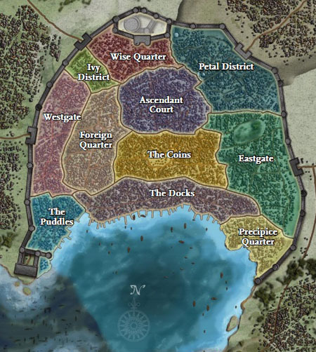
Key NPCs:
- Drandle Dreng: Venture-Captain responsible for the records of Absalom's history and mysteries.
- Emral Xarcious: Taldan scholar known in some circles for his (poor) gambling habits.
  - Creeley Greeves: a bookie from the Puddles.
- Sewer Dragons: a prominent gang of kobolds purported to have a dragon under their control.

Other Information:
- Kobolds: though known for being cowardly, kobolds can be surprisingly ingenious, particularly with traps. Absalom's sewers are infested with the creatures.
- Reports: surviving agents claimed to have been attacked by a large dragon, while investigations revealed scorch marks on the walls wherever Pathfinders were attacked.

