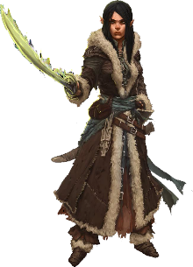  Eramay, The Loyalist  Female Half-Elf Cavalier 8  Eramay proudly graduated as part of Erages Academy’s first class with a focus in esoteric religions and swordplay—training that caught the Pathfinder Society’s attention and earned her accelerated admission. Her faith in the Society diminished over time thanks to the unpolished leadership of venture-captains and the Grand Lodge’s often irresponsible mishandling of dangerous artifacts. |  | 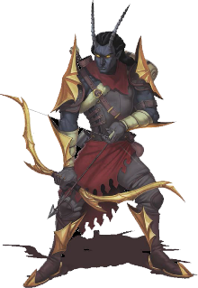  Falth, The Catastrophe  Male Tiefling Inquisitor 8  Falth’s life has been a string of unfortunate accidents. He was born with fiendish features to human parents in Korvosa.An accident. His mother left him behind at a dingy orphanage after he was born. It could only be an accident. The orphanage “ran out of beds” and kicked him to the streets.
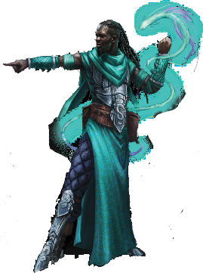  Rataji, The Disgraced  Male Human Enchanter 8  The affable Rataji entered the prestigious Magaambya academy of arcane knowledge at a young age. There he amazed both his instructors and his classmates with his mastery of subtler spells, and few doubted that he might one day enter the ranks of the honored Tempest-Sun mages. |  | 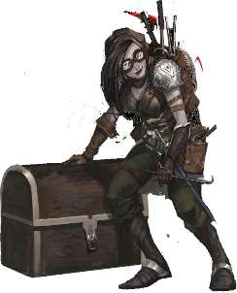  Shohiraj, The Professional  Human Unchained Rogue 8  Danger was always a girlish fancy for the young sisters Aima and Halna Deschamp, who grew up just outside Oppara. There the two were never far from the bardic colleges and their students, who gushed odes of great heroes and dashing duelists to any who cared to listen. The older Aima gradually outgrew these stories, but Halna longed to live a life of swashbuckling adventure.
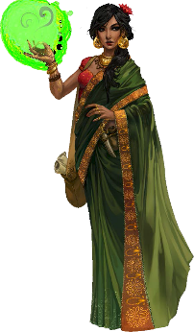  Thestil Shadow Tongue,  The Enigma  Female doppelganger mesmerist 4  Consortium leadership sometimes pokes fun at what they perceive as Thestil’s overdramatic “mysterious stranger” shtick, but they cannot doubt her effectiveness. She has twice turned down promotion to silver agent, so her superiors have instead issued her an elaborate bronze badge to recognize her feats without imposing further responsibilities. |  | 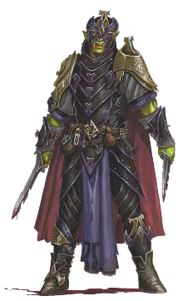  Zurnzal, The Ambitious  Male Half-Orc Brawler 6/  Assassin 2  Although some half-orcs born in Lastwall find acceptance, many green-skinned children raised in that border nation wither under the accusing gazes of warrior families that have lost loved ones to the orc hordes. Zurnzal grew up burdened by his neighbors’ assumptions, who often assumed he might yet become a feral beast, despite his gentle heart and service to the community.

Player Reference Sheet

The Aspis Consortium

The Aspis Consortium is an unscrupulous multinational trade organization based in Ostenso, Cheliax, but with interests in many parts of Avistan and Garund.
Presenting Evil

Serpents’ Ire presents a rare opportunity in the Pathfinder Society Organized Play campaign to portray evil characters. Even so, it is important that players exercise some restraint. After all, one can be deviously villainous without being a reckless sociopath. Some of the pregenerated characters might even be willing to take extraordinary—arguably heroic—risks in the name of their cause and comrades. Even members of the Aspis Consortium know when to set aside their rivalries and get a job done. Let evil alignments flavor the adventure, not spoil the fun.
When running this in a public setting with strangers, let the players know that the fundamentals of the organized play campaign are still in effect: don’t kill each others’ characters and don’t be a jerk. While everyone is getting settled, discuss the option with your group and decide where the line is between evil and obnoxiousness. No matter what, be mindful of your audience, and be prepared to rein in the tone if anyone’s depictions of evil actions become too distasteful.
Evidence Points

Over the course of the adventure, the PCs accumulate Evidence Points, which serve as an abstract representation of how much valuable intelligence they have recovered. Unless the PCs do something stupid, they cannot lose Evidence Points. Their actions can, however, reduce the number of Evidence Points available in a location. Evidence Points indicate the PCs’ overall success at the end of the adventure.

