BLENTA
Storm-Screamers of Rull Tribe
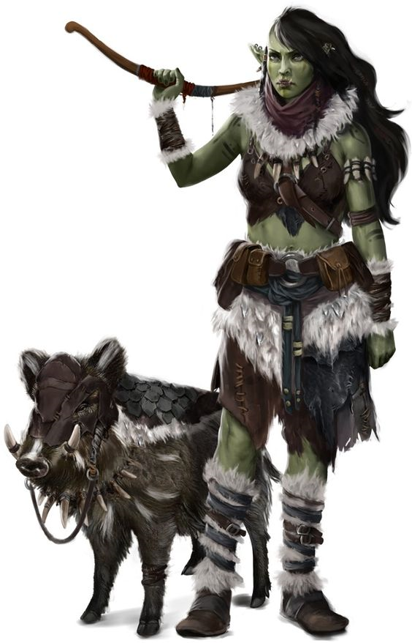
LIKES: Animals, Nature, Sex and the City
BORBUS
Cleft Head Tribe
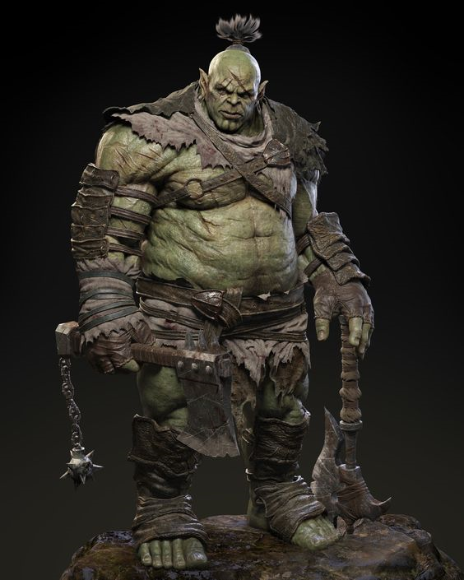
LIKES: Alcohol, Entertainment, Stories, Long Walks on the Beach
BORBUS

AVERAGE DC
Perform (any), Sleight of Hand
HARD DC
Bluff, Escape Artist

Special: Anyone who gives him alcohol gains a +4 on these checks.

BENEFIT
Before attempting a Bluff, Escape Artist, Perform, or Sleight of Hand check, you can decide to roll twice and take the higher result. Each PC can use this once during this scenario.

BLENTA

AVERAGE DC
Handle Animal, Wild Empathy
HARD DC
CMB, Knowledge (nature), Ride

Special: Anyone with an animal companion gets +2 on these checks.

BENEFIT
+1 to hit and damage vs animals and magical beasts for the rest of the scenario.

BUKOG
Steel Eater Tribe
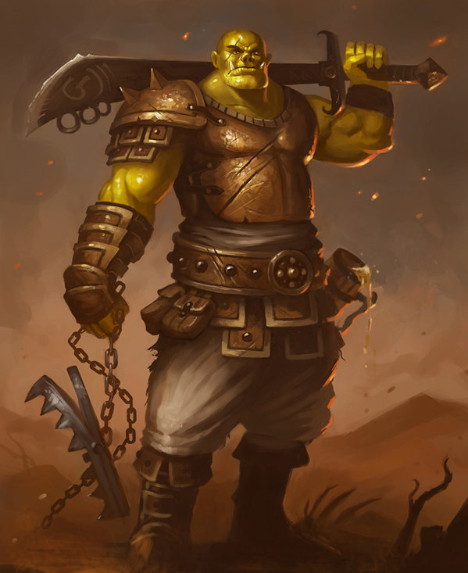
LIKES: Crafting, Metalworking, Justin Bieber

GEKGARO
Broken Spine Tribe
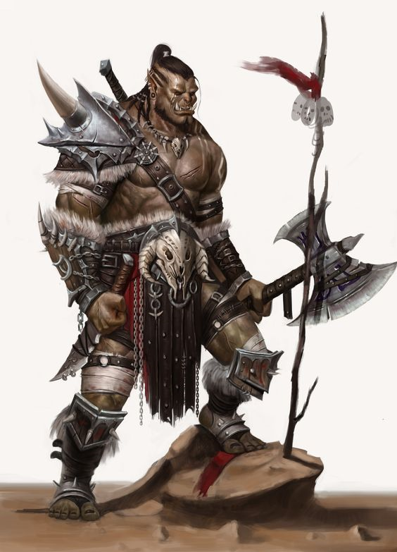
LIKES: Survival, Geography, Dubstep
GEKGARO

AVERAGE DC
Knowledge (geography), Survival
HARD DC
Knowledge (history or nature)

Special: Anyone who mentions they’re a Pathfinder or who wears a Wayfinder takes a -4 on these checks.

BENEFIT
Gain the Nimble Moves feat for the rest of this scenario.

BUKOG

AVERAGE DC
Appraise, Craft (any)
HARD DC
Spellcraft, Use Magic Device

BENEFIT
+5 on any Day Job check at the end of this scenario.

GRAFFA
Burning Sun Tribe
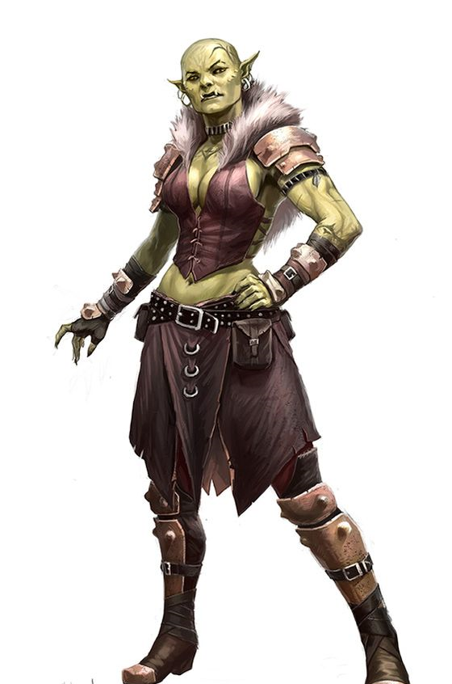
LIKES: Competition, Athletics, Chanel #5
KARDOOK
Bloodied Gauntlet Tribe
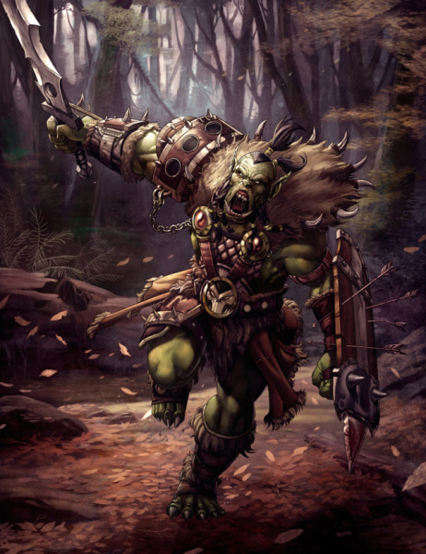
LIKES: Combat, Warriors, Gorum, Bubble Baths
KARDOOK

AVERAGE DC
Intimidate, Profession (soldier)
HARD DC
CMB, Knowledge (engineering)

Special: Anyone wearing a holy symbol of Gorum gains a +2 on these checks. Anyone speaking positively about crusaders, paladins, or Lastwall take a -4 on these checks.

BENEFIT
Use Martial Flexibility (gain a Combat Feat for 1 minute as a Move Action) once during this scenario. If you already have Martial Flexibility, you gain 1 additional use of it before the end of this scenario.

GRAFFA

AVERAGE DC
Climb, Escape Artist, Swim
HARD DC
Acrobatics

Special: Female PCs gain a +2 o these checks.

BENEFIT
Gain either the Acrobatic or the Athletic feat for the rest of this scenario

MIRTGOG
Murdered Child Tribe
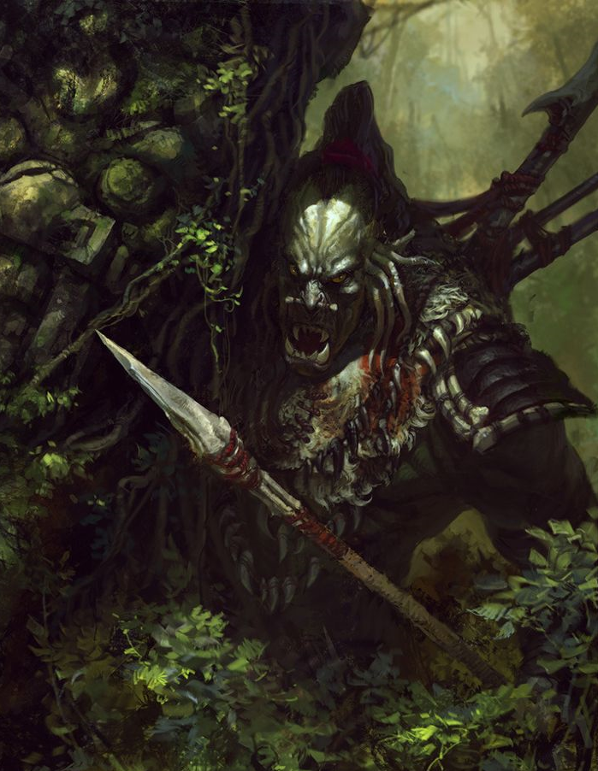
LIKES: Information, Stealth, Crayola Crayons
MIRTGOG
Murdered Child Tribe
LIKES: Information, Stealth, Crayola Crayons
MIRTGOG

AVERAGE DC
Sleight of Hand
HARD DC
Disable Device, Stealth

BENEFIT
At the start of an encounter, gain the Precise Strike Teamwork Feat for the rest of that encounter. Each PC can use this once during this scenario.

MIRTGOG

AVERAGE DC
Sleight of Hand
HARD DC
Disable Device, Stealth

BENEFIT
At the start of an encounter, gain the Precise Strike Teamwork Feat for the rest of that encounter. Each PC can use this once during this scenario.

BLENTA
Storm-Screamers of Rull Tribe
LIKES: Animals, Nature, Sex and the City
BORBUS
Cleft Head Tribe
LIKES: Alcohol, Entertainment, Stories, Long Walks on the Beach
BORBUS

AVERAGE DC
Perform (any), Sleight of Hand
HARD DC
Bluff, Escape Artist

Special: Anyone who gives him alcohol gains a +4 on these checks.

BENEFIT
Before attempting a Bluff, Escape Artist, Perform, or Sleight of Hand check, you can decide to roll twice and take the higher result. Each PC can use this once during this scenario.

BLENTA

AVERAGE DC
Handle Animal, Wild Empathy
HARD DC
CMB, Knowledge (nature), Ride

Special: Anyone with an animal companion gets +2 on these checks.

BENEFIT
+1 to hit and damage vs animals and magical beasts for the rest of the scenario.

BUKOG
Steel Eater Tribe
LIKES: Crafting, Metalworking, Justin Bieber

GEKGARO
Broken Spine Tribe
LIKES: Survival, Geography, Dubstep
GEKGARO

AVERAGE DC
Knowledge (geography), Survival
HARD DC
Knowledge (history or nature)

Special: Anyone who mentions they’re a Pathfinder or who wears a Wayfinder takes a -4 on these checks.

BENEFIT
Gain the Nimble Moves feat for the rest of this scenario.

BUKOG

AVERAGE DC
Appraise, Craft (any)
HARD DC
Spellcraft, Use Magic Device

BENEFIT
+5 on any Day Job check at the end of this scenario.

GRAFFA
Burning Sun Tribe
LIKES: Competition, Athletics, Chanel #5
KARDOOK
Bloodied Gauntlet Tribe
LIKES: Combat, Warriors, Gorum, Bubble Baths
KARDOOK

AVERAGE DC
Intimidate, Profession (soldier)
HARD DC
CMB, Knowledge (engineering)

Special: Anyone wearing a holy symbol of Gorum gains a +2 on these checks. Anyone speaking positively about crusaders, paladins, or Lastwall take a -4 on these checks.

BENEFIT
Use Martial Flexibility (gain a Combat Feat for 1 minute as a Move Action) once during this scenario. If you already have Martial Flexibility, you gain 1 additional use of it before the end of this scenario.

GRAFFA

AVERAGE DC
Climb, Escape Artist, Swim
HARD DC
Acrobatics

Special: Female PCs gain a +2 o these checks.

BENEFIT
Gain either the Acrobatic or the Athletic feat for the rest of this scenario

